










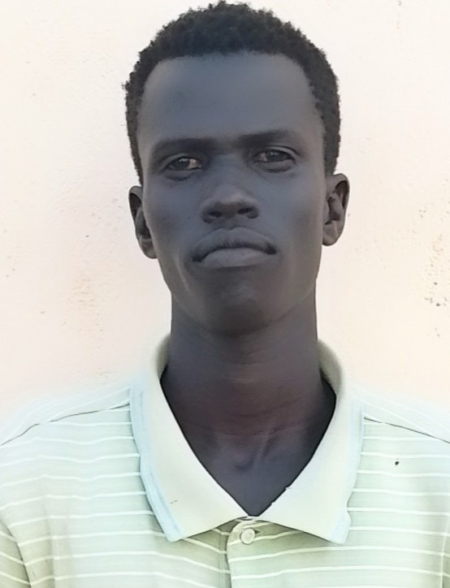
FOOTBALL KENYA FEDERATION
Football Amateur
DESERT WARRIORS FC
Rift valley
Ebenyo Amuria
02-Feb-2002
Kenya
FKF074135
FOOTBALL KENYA FEDERATION
Football Amateur
DESERT WARRIORS FC
Rift valley
EUgine Barasa
05-Feb-2002
Kenya
FKF129398
FOOTBALL KENYA FEDERATION
Football Amateur
DESERT WARRIORS FC
Rift valley
Kuo Deng
01-Jan-1995
South Sudan
FKF136903
FOOTBALL KENYA FEDERATION
Football Amateur
DESERT WARRIORS FC
Rift valley
Gideon Edung
15-Jun-2002
Kenya
FKF074131
FOOTBALL KENYA FEDERATION
Football Amateur
DESERT WARRIORS FC
Rift valley
John Ekiru
06-Feb-1995
Kenya
FKF134148
FOOTBALL KENYA FEDERATION
Football Amateur
DESERT WARRIORS FC
Rift valley
Ngitelejio Epua
21-Dec-2006
Kenya
FKF074140
2025/26 - PLAYER
2025/26 - PLAYER
2025/26 - PLAYER
2025/26 - PLAYER
2025/26 - PLAYER
2025/26 - PLAYER












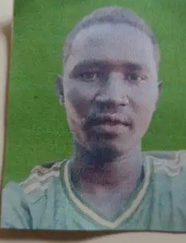
FOOTBALL KENYA FEDERATION
Football Amateur
DESERT WARRIORS FC
Rift valley
Brian Epus
06-Jul-2006
Kenya
FKF129399
FOOTBALL KENYA FEDERATION
Football Amateur
DESERT WARRIORS FC
Rift valley
Sylvester Erika
02-Oct-1994
Kenya
FKF074174
FOOTBALL KENYA FEDERATION
Football Amateur
DESERT WARRIORS FC
Rift valley
Joshua Erupe
30-Jan-2003
Kenya
FKF134162
FOOTBALL KENYA FEDERATION
Football Amateur
DESERT WARRIORS FC
Rift valley
Etoot Esekon
05-Jan-1995
Kenya
FKF074729
FOOTBALL KENYA FEDERATION
Football Amateur
DESERT WARRIORS FC
Rift valley
Devid Esinyen
27-Jan-2001
Kenya
FKF134157
FOOTBALL KENYA FEDERATION
Football Amateur
DESERT WARRIORS FC
Rift valley
Desmond Eyanae
20-Dec-2006
Kenya
FKF134161
2025/26 - PLAYER
2025/26 - PLAYER
2025/26 - PLAYER
2025/26 - PLAYER
2025/26 - PLAYER
2025/26 - PLAYER













FOOTBALL KENYA FEDERATION
Football Amateur
DESERT WARRIORS FC
Rift valley
MOSES EYANAE
10-Feb-1999
Kenya
FKF074207
FOOTBALL KENYA FEDERATION
Football Amateur
DESERT WARRIORS FC
Rift valley
Ichapi Joseph
04-Aug-2004
Kenya
FKF083300
FOOTBALL KENYA FEDERATION
Football Amateur
DESERT WARRIORS FC
Rift valley
Samuel Kai
17-Aug-2006
Kenya
FKF129397
FOOTBALL KENYA FEDERATION
Football Amateur
DESERT WARRIORS FC
Rift valley
Moses Kaikir
15-Mar-2001
Kenya
FKF083301
FOOTBALL KENYA FEDERATION
Football Amateur
DESERT WARRIORS FC
Rift valley
Robinson Kaunga
21-Jan-1997
Kenya
FKF133077
FOOTBALL KENYA FEDERATION
Football Amateur
DESERT WARRIORS FC
Rift valley
Erick Lodunga
01-Apr-2004
Kenya
FKF133076
2025/26 - PLAYER
2025/26 - PLAYER
2025/26 - PLAYER
2025/26 - PLAYER
2025/26 - PLAYER
2025/26 - PLAYER













FOOTBALL KENYA FEDERATION
Football Amateur
DESERT WARRIORS FC
Rift valley
Isaac Logiron
20-Sep-2002
Kenya
FKF074138
FOOTBALL KENYA FEDERATION
Football Amateur
DESERT WARRIORS FC
Rift valley
Derrick Lokarach
04-Feb-2002
Kenya
FKF082447
FOOTBALL KENYA FEDERATION
Football Amateur
DESERT WARRIORS FC
Rift valley
EMMANUEL LOKWAMEKWI LOKOL
06-Oct-2002
Kenya
FKF074198
FOOTBALL KENYA FEDERATION
Football Amateur
DESERT WARRIORS FC
Rift valley
MICAH LOMURIA
10-Oct-1995
Kenya
FKF025137
FOOTBALL KENYA FEDERATION
Football Amateur
DESERT WARRIORS FC
Rift valley
Kevin Losikiria
06-Apr-2000
Kenya
FKF134150
FOOTBALL KENYA FEDERATION
Football Amateur
DESERT WARRIORS FC
Rift valley
Militon Lotipok
05-Apr-2003
Kenya
FKF134164
2025/26 - PLAYER
2025/26 - PLAYER
2025/26 - PLAYER
2025/26 - PLAYER
2025/26 - PLAYER
2025/26 - PLAYER













FOOTBALL KENYA FEDERATION
Football Amateur
DESERT WARRIORS FC
Rift valley
David Nakadon
03-Apr-2004
Kenya
FKF074130
FOOTBALL KENYA FEDERATION
Football Amateur
DESERT WARRIORS FC
Rift valley
Imuse Nakali
03-Aug-1998
Kenya
FKF132405
FOOTBALL KENYA FEDERATION
Football Amateur
DESERT WARRIORS FC
Rift valley
Daniel Narwa
25-May-2005
Kenya
FKF134168
FOOTBALL KENYA FEDERATION
Football Amateur
DESERT WARRIORS FC
Rift valley
Ggitira Olan
02-Dec-2002
Kenya
FKF134173
FOOTBALL KENYA FEDERATION
Football Amateur
DESERT WARRIORS FC
Rift valley
Dennis Titea
05-Aug-2005
Kenya
FKF074141
FOOTBALL KENYA FEDERATION
Football Amateur
DESERT WARRIORS FC
Rift valley
EPAE VICTOR
09-Nov-1999
Kenya
FKF082635
2025/26 - PLAYER
2025/26 - PLAYER
2025/26 - PLAYER
2025/26 - PLAYER
2025/26 - PLAYER
2025/26 - PLAYER



FOOTBALL KENYA FEDERATION
Football Amateur
DESERT WARRIORS FC
Rift valley
Wekesa Wamalwa
20-Dec-1996
Kenya
FKF074357
2025/26 - PLAYER

